ELECENG 3CL4 – Pre Lab 5
Phase Lead-Lag Compensator Design Using Root Locus

April 2nd, 2026

Amaiam Ul Haque – haquea24 – 400520641 – L07 – C02
Jumana Ismail – ismailj – 400507846 – L07 – C02

Plagiarism Statement
As a future member of the engineering profession, the student is responsible for performing the required work in an honest manner, without plagiarism and cheating. Submitting this work with my name and student number is a statement and understanding that this work is my own and adheres to the Academic Integrity Policy of McMaster University and the Code of Conduct of the Professional Engineers of Ontario. Submitted by [Amaiam Ul-Haque, haquea24, 400520641]
As a future member of the engineering profession, the student is responsible for performing the required work in an honest manner, without plagiarism and cheating. Submitting this work with my name and student number is a statement and understanding that this work is my own and adheres to the Academic Integrity Policy of McMaster University and the Code of Conduct of the Professional Engineers of Ontario. Submitted by [Jumana Ismail, ismailj, 400507846]

Individual Contributions

Introduction

Pre-Lab Questions

Pre-Lab Question 1
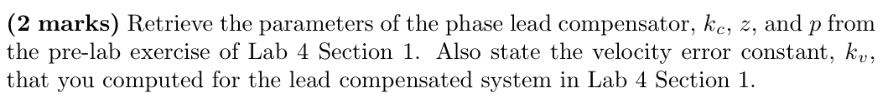
$$k_{c}=11.33 \\ z=4 \\ p=9.54 \\ k_{v}=6.98$$

Pre-Lab Question 2
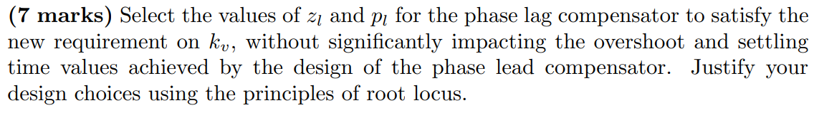
$$k_{v}=10×k_{v, lab4}=10×7=70 \\ k_{v}=\frac{z_{l}}{p_{l}}=10 \\ p_{l}=0.001 , { z}_{l}=0.01$$To ensure minimal impact on the transient response, very small values of z_{l} and p_{l} are chosen, so once the remaining poles and zeroes that are further away start off the initial transient response and the terms decay, these smaller values make an impact on the steady state response instead of the transient response.
The resulting controller transfer function:
$$G_{c}\left(s\right)=k_{c}×\frac{s+z}{s+p}×\frac{s+z_{l}}{s+p_{l}}=11.33\frac{s+4}{s+9.54}\frac{s+0.01}{s+0.001}$$

Pre-Lab Question 3
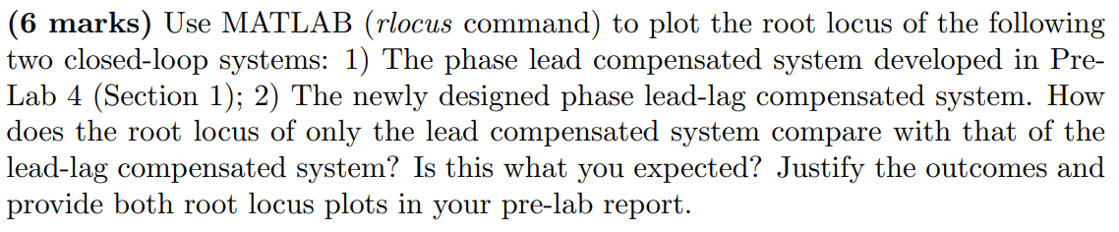
Matlab code used:
%% Elec3CL4_Lab5_Q3

% using "Control System Toolbox"

s = tf('s');

% plant transfer function
G = 4.7 / (s*(s+3.2));

% controller transfer function
kc = 11.33;
z_lead = 4;
p_lead = 9.54;
z_lag = 0.01;
p_lag = 0.001;

G_c_lead = kc * (s+z_lead)/(s+p_lead);
G_c_lag = (s+z_lag)/(s+p_lag);
G_c_lead_lag = G_c_lead * G_c_lag;

% plot root locus
figure
rlocus(G_c_lead*G)
title('Root Locus of Lead Compensated System')
grid on

figure
rlocus(G_c_lead_lag*G)
title('Root Locus of Lead-Lag Compensated System')
grid on
Resulting Matlab figures:
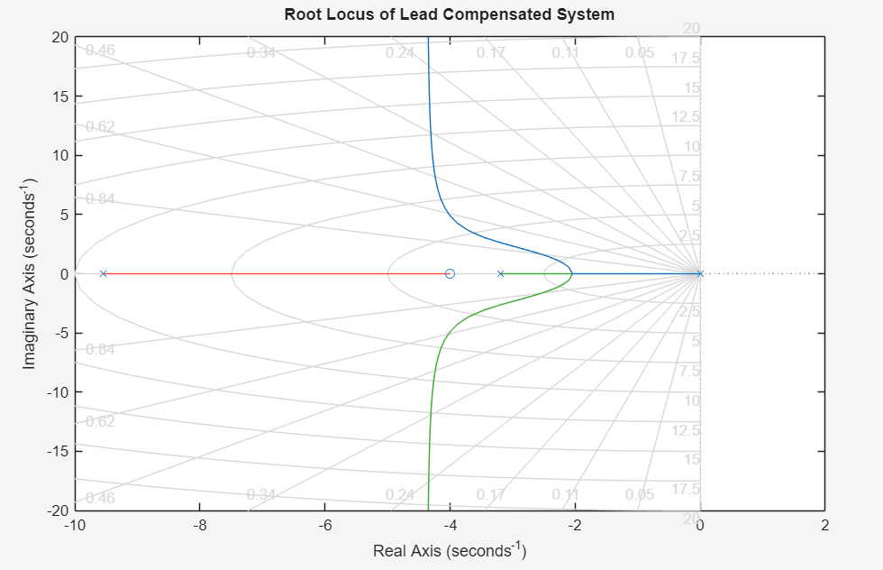
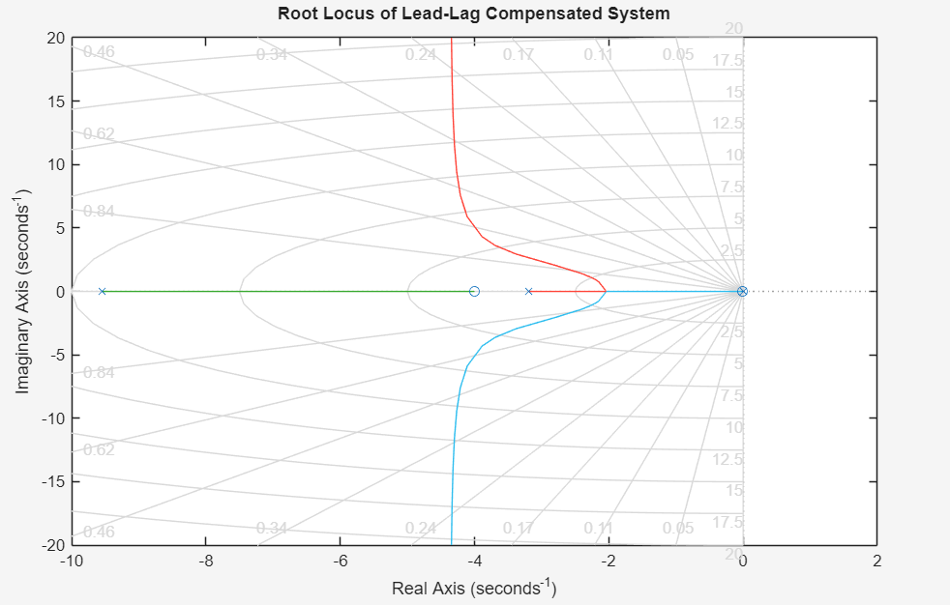
The lead-lag system's root locus near the dominant poles looks almost the same as the lead-only system. This is because the lag compensator's pole and zero are placed near the origin, boosting steady-state gain without changing the dominant poles much. However, in lab experiments, we can't use such small pole and zero values due to time constraints.
New p_{l} and z_{l} are chosen to fit within constraints while maintaining the ratio.
$$k_{v}=\frac{z_{l}}{p_{l}}=10 \\ p_{l}=0.01 , { z}_{l}=0.1$$The new resulting controller transfer function:
$$G_{c}\left(s\right)=k_{c}×\frac{s+z}{s+p}×\frac{s+z_{l}}{s+p_{l}}=11.33\frac{s+4}{s+9.54}\frac{s+0.1}{s+0.01}$$

Adjusted Matlab code with changes highlighted:
%% Elec3CL4_Lab5_Q3

% using "Control System Toolbox"

s = tf('s');

% plant transfer function
G = 4.7 / (s*(s+3.2));

% controller transfer function
kc = 11.33;
z_lead = 4;
p_lead = 9.54;
z_lag = 0.1;
p_lag = 0.01;

G_c_lead = kc * (s+z_lead)/(s+p_lead);
G_c_lag = (s+z_lag)/(s+p_lag);
G_c_lead_lag = G_c_lead * G_c_lag;

% plot root locus
figure
rlocus(G_c_lead*G)
title('Root Locus of Lead Compensated System')
grid on

figure
rlocus(G_c_lead_lag*G)
title('Root Locus of Lead-Lag Compensated System')
grid on
Resulting Matlab figures:

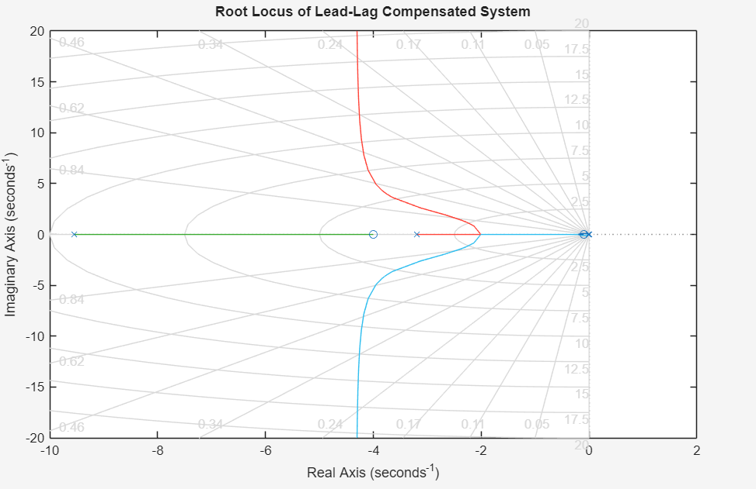
The new lead lag design’s root locus still looks relatively similar to the lead design’s however with a very slight impact on the root locus as compared to the previous lead lag design as it is further away from the origin and contributes more to the transient response.

Pre-Lab Question 4
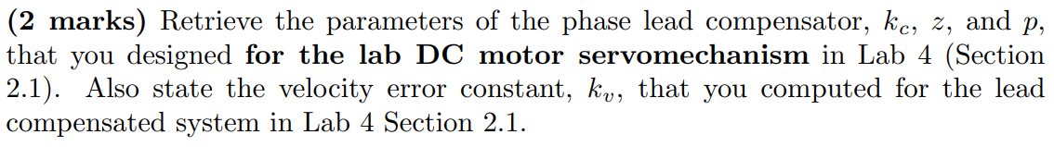
$$k_{c}=1.87 \\ z=13.33 \\ p=31.31 \\ k_{v}=23.25$$

Pre-Lab Question 5
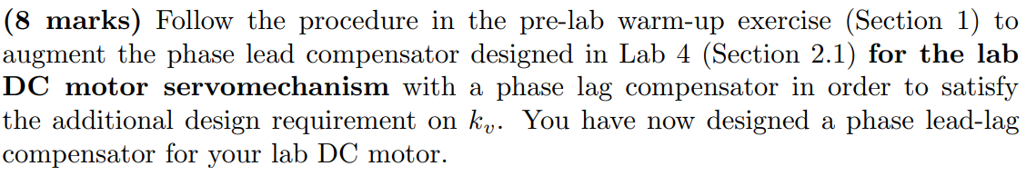
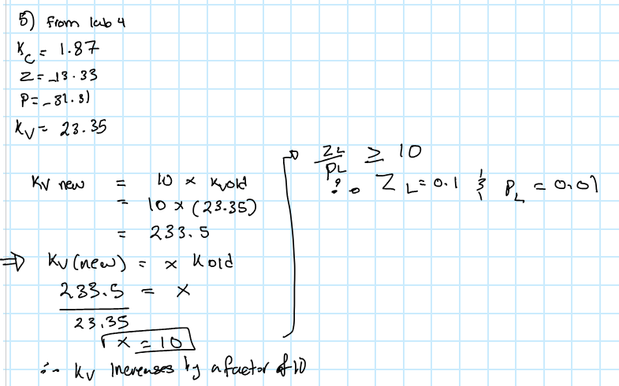

Pre-Lab Question 6
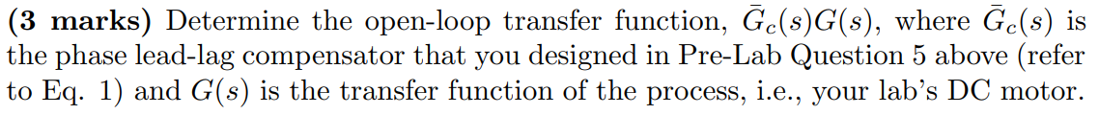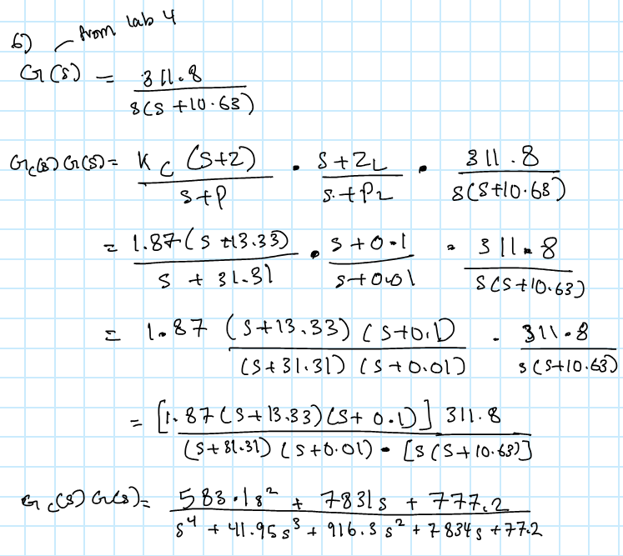
Matlab Code: **just to get the transfer function
%% Elec3CL4_Lab5_Q6

% using "Control System Toolbox"

s = tf('s');

% lab station plant transfer function
G = 311.8 / (s*(s+10.62));

% lab station controller transfer function
kc = 1.87;
z_lead = 13.33;
p_lead = 31.31;
z_lag = 0.1;
p_lag = 0.01;

G_c_lead = kc * (s+z_lead)/(s+p_lead);
G_c_lag = (s+z_lag)/(s+p_lag);
G_c_lead_lag = G_c_lead * G_c_lag;

% print open loop transfer function
title('Open Loop Transfer Function of Phase Lead Lag Compensator:')
disp(G_c_lead_lag*G)

Pre-Lab Question 7
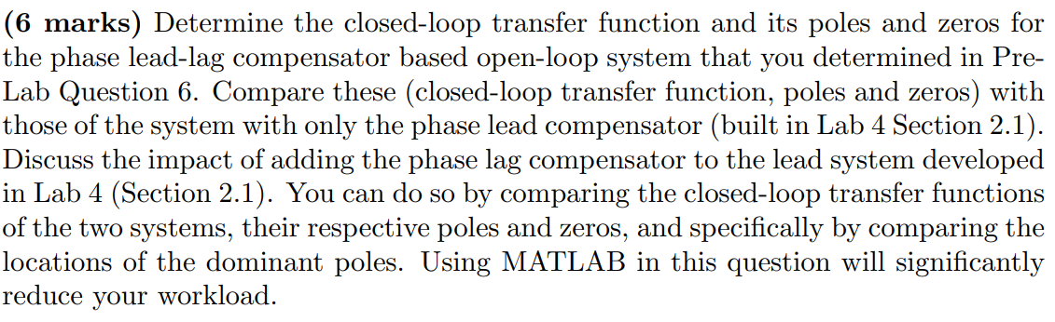From the MATLAB code’s output, observed the following:
The closed-loop Transfer function:
Its poles & zeros:
From lab 4 section 2.1, the closed loop transfer function along with its poles and zeros (only phase lead compensator)
As seen from both results, the closed loop transfer function of the phase lead system is third order, while the phase lead lag system becomes fourth order due to the addition of the lag component. The lead system has a zero at s = -13.33, as for the lead-lag system it has two zeros at s = -13.33 and s = -0.1. As for the poles, the lead system has three poles while the lead lag system has four poles, thus more by one thats near the origin at s = -0.1. Thats because the lag compensator s+zl/s+pl adds a pole-zero pair to the controller.

As for the root locus plots, when comparing the dominant poles in both cases, they are location around the same positions in the complex plane, this shows that the transient response (i.e. P.O. and Ts) remains unchanged. Thus, the additional pole-zero pair introduced by the lag compensator is close to the origin and far from the dominant poles, that means it only affects slow steady state behaviour such as kv, where it will increase it, but has minimal impact on the dominant poles as they are far from the origin.

Matlab code:
%% Elec3CL4_Lab5_Q7
% using "Control System Toolbox"

s = tf('s');

% lab station plant transfer function
G = 311.8 / (s*(s+10.62));

% lab station controller transfer function
kc = 1.87;
z_lead = 13.33;
p_lead = 31.31;
z_lag = 0.1;
p_lag = 0.01;

G_c_lead = kc * (s+z_lead)/(s+p_lead);
G_c_lag = (s+z_lag)/(s+p_lag);
G_c_lead_lag = G_c_lead * G_c_lag;

% print closed loop transfer functions
disp('Closed Loop Transfer Function of Lead Compensator:')
T_lead = feedback(G_c_lead*G, 1)

disp('Closed Loop Transfer Function of Lead-Lag Compensator:')
T_lead_lag = feedback(G_c_lead_lag*G, 1)

% print poles and zeroes
disp('Poles of Lead Compensator:')
pole(T_lead)
disp('Zeroes of Lead Compensator:')
zero(T_lead)

disp('Poles of Lead-Lag Compensator:')
pole(T_lead_lag)
disp('Zeroes of Lead-Lag Compensator:')
zero(T_lead_lag)
% plot root locus
figure
rlocus(G_c_lead*G)
title('Root Locus of Lead Compensated System')
grid on

figure
rlocus(G_c_lead_lag*G)
title('Root Locus of Lead-Lag Compensated System')
grid on

Pre-Lab Question 8
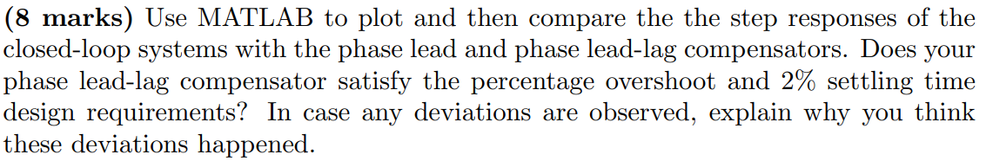Step Responses of both systems:
From Matlab:
Lead compensator system: Ts = 0.2657s, P.O. = 14.17%
Lead-lag compensator system: Ts = 0.2703, P.O. = 14.69%
From the results above, it is seen that both the lead and lead lag systems satisfy the 2% settling time requirement of around 0.3s. However, both systems exceed the 10% overshoot requirement, with overshoots of 14.17% and 14.69%. The lead lag compensator does not significantly change the transient response as seen from the plot where the lead lag step response very closely follows the lead step response. The small increase in the P.O. of the lead lag happens because the system is not perfectly a second order system similarly to the lead system (its not perfectly a 2nd order system, its P.O. is also greater than 10% as discussed in lab4) as assumed in the lab design (which is designed for 2nd order system). Moreover, the added lag pole zero pair slightly affect the response since the pole zero pair is placed near the origin, the mainly affects the steady state behaviour of improving kv while causing minor change in the transient response where its slightly higher than the lead system.
Matlab code:
%% Elec3CL4_Lab5_Q8
% using "Control System Toolbox"

s = tf('s');

% lab station plant transfer function
G = 311.8 / (s*(s+10.62));

% lab station controller transfer function
kc = 1.87;
z_lead = 13.33;
p_lead = 31.31;
z_lag = 0.1;
p_lag = 0.01;

G_c_lead = kc * (s+z_lead)/(s+p_lead);
G_c_lag = (s+z_lag)/(s+p_lag);
G_c_lead_lag = G_c_lead * G_c_lag;

% closed loop transfer functions
T_lead = feedback(G_c_lead*G, 1);
T_lead_lag = feedback(G_c_lead_lag*G, 1);

% step response plots
figure
step(T_lead)
hold on
step(T_lead_lag)
legend('Lead', 'Lead-Lag')
grid on

% step response info
disp('Lead Compensator System:')
stepinfo(T_lead)
disp('Lead Lag Compensator System:')
stepinfo(T_lead_lag)

Pre-Lab Question 9
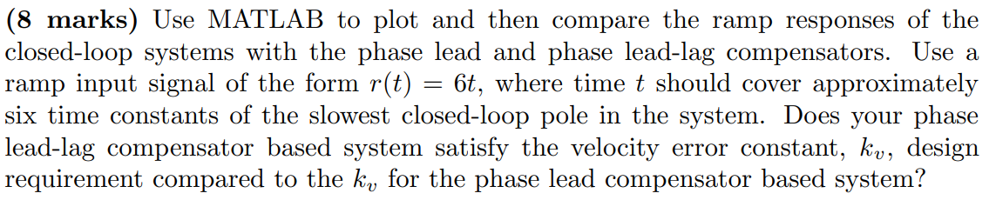Matlab’s output:
As seen from the ramp response results above, the lead compensator has a kv = 23.3744 while the lead lag compensator has a kv = 233.7439, almost 10 times larger. This means that the design requirement of increasing kv by a factor of 10 is satisfied. Additionally, the steady state error, ess, decreases from 0.2567 (lead) to 0.0257 (lead-lag) which is approximately 10 times smaller. The ramp response plot confirms that the lead lag system tracks the input even more closely than the lead system. Thus, it's concluded that the phase lead lag compensator improves steady state performance as seen by the plot while maintaining similar transit behaviour and meeting the design requirement of making kv larger.
Matlab code:
%% Elec3CL4_Lab5_Q9
% using "Control System Toolbox"

s = tf('s');

% lab station plant transfer function
G = 311.8 / (s*(s+10.62));

% lab station controller transfer function
kc = 1.87;
z_lead = 13.33;
p_lead = 31.31;
z_lag = 0.1;
p_lag = 0.01;

G_c_lead = kc * (s+z_lead)/(s+p_lead);
G_c_lag = (s+z_lag)/(s+p_lag);
G_c_lead_lag = G_c_lead * G_c_lag;

% closed loop transfer functions
T_lead = feedback(G_c_lead*G, 1);
T_lead_lag = feedback(G_c_lead_lag*G, 1);

% ramp input
t = 0:0.01:100;
A = 6;
u=A*t;

y_lead = lsim(T_lead, u, t);
y_lead_lag = lsim(T_lead_lag, u, t);

% ramp response plots
figure
plot(t,u,'k', 'LineWidth', 1.5)
hold on
plot(t,y_lead,'r', 'LineWidth', 1.5)
plot(t,y_lead_lag,'b', 'LineWidth', 1.5)
title('Ramp Response')
xlabel('Time (s)')
ylabel('Output \theta(t)')
legend('Input r(t) = 6t', 'Lead Compensator', 'Lag Compensator', 'Location', 'best')
grid on

% kv
disp('Lead Compensator kv:')
kv_lead = dcgain(s*G_c_lead*G)
disp('Lead-Lag Compensator kv:')
kv_lead_lag = dcgain(s*G_c_lead_lag*G)

% ess
disp('Lead Compensator ess:')
ess_lead = A/kv_lead
disp('Lead-Lag Compensator ess:')
ess_lead_lag = A/kv_lead_lag

